**PROPERTY ANALYSIS BI DEVELOPER- STANDARD SPRINT - PART 5- BUILD POWER BI DASHBOARD FROM YOUR DESIGNED DATAWAREHOUSE**

**Task 25 : Given suburb and city, display median rental value, median yearly income, and value changes of the property within 1 km radius**

**Step 1: Write a stored procedure in Microsoft SQL Server Management Studio**

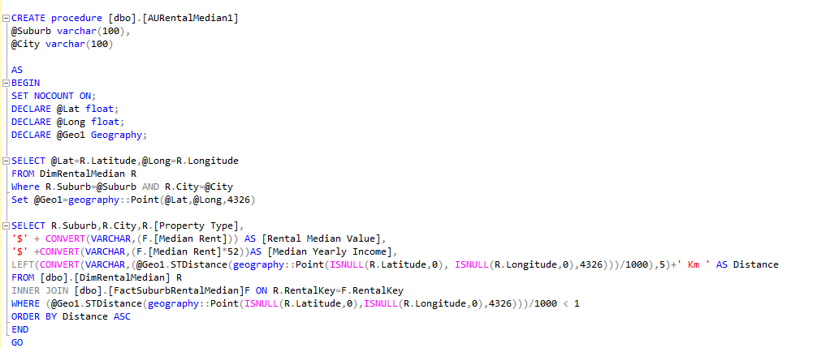**Step 2: Connect to the Server, Database and Import the data using stored procedure in Power BI**

**Step 3: Create a list for Suburb and City .Create a new parameter for Suburb and City. Pass the parameter in the function.**

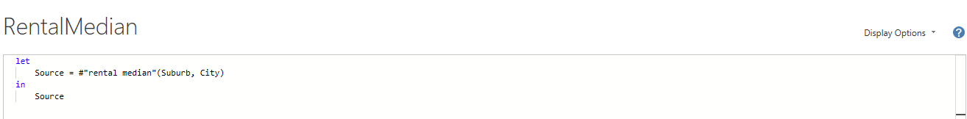

**Step 4: Select the Suburb and City to display the result accordingly**

**SAMPLE OUTPUT:**

**Task 26: Given suburb and city, display local public transport within 1km radius**

**Step 1: Write a stored procedure in Microsoft SQL Server Management Studio**

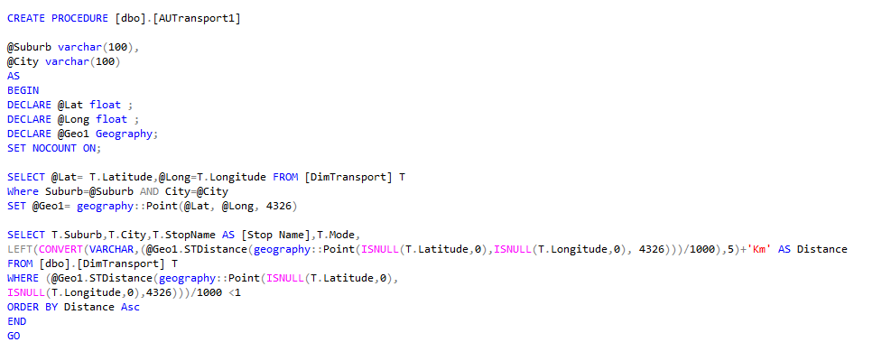

**Step 2: Connect to the Server, Database and Import the data using stored procedure in Power BI**

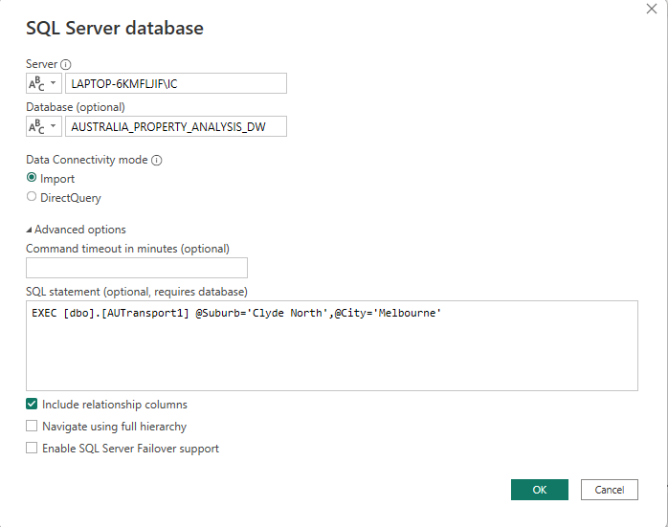

**Step 3: Create a list for Suburb and City. Create a new parameter for Suburb and City. Pass the parameter in the function.**

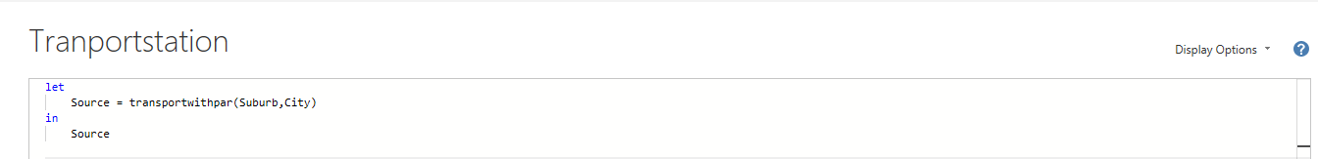

**Step 4: Select the Suburb and City to display the result accordingly**

**SAMPLE OUTPUT:**

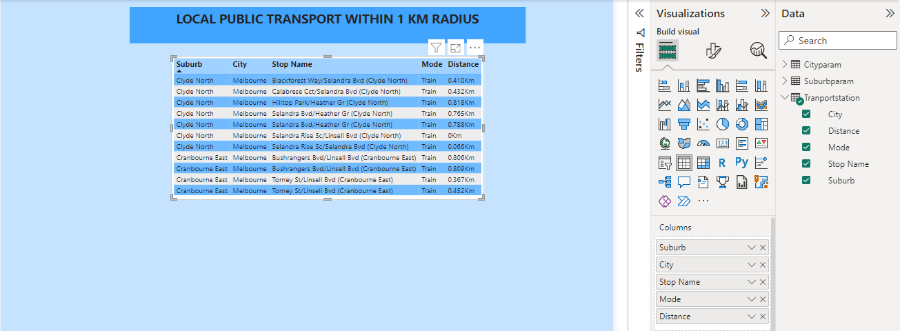

**Task 27: Given suburb and city, display local schools within 1km radius**

**Step 1: Write a stored procedure in Microsoft SQL Server Management Studio**

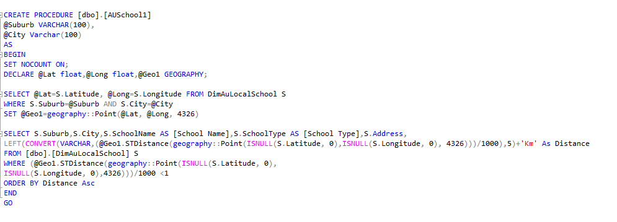

**Step 2: Connect to the Server, Database and Import the data using stored procedure in Power BI**

**Step 3: Create a list for Suburb and City. Create a new parameter for Suburb and City. Pass the parameter in the function.**

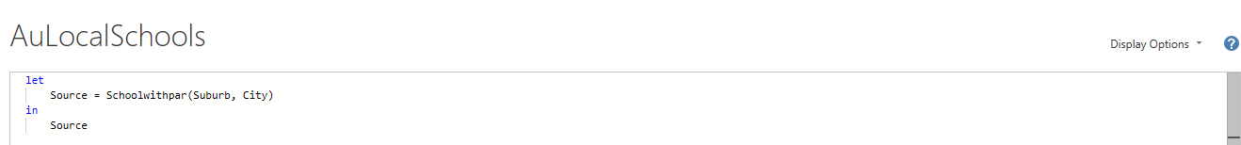

**Step 4: Select the Suburb and City to display the result accordingly**

**SAMPLE OUTPUT:**

**Task 28: Given suburb and city, display crime rate within 1 km radius**

**Step 1: Write a stored procedure in Microsoft SQL Server Management Studio**

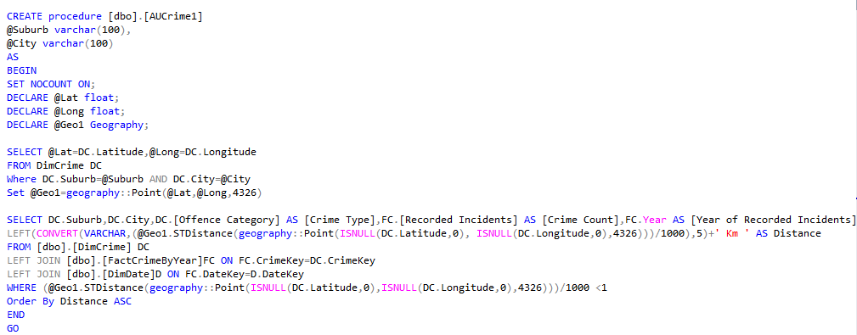

**Step 2: Connect to the Server, Database and Import the data using stored procedure in Power BI**

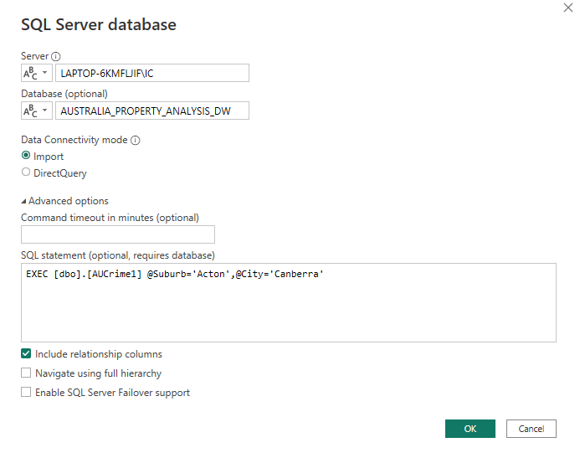

**Step 3: Create a list for Suburb and City. Create a new parameter for Suburb and City. Pass the parameter in the function.**

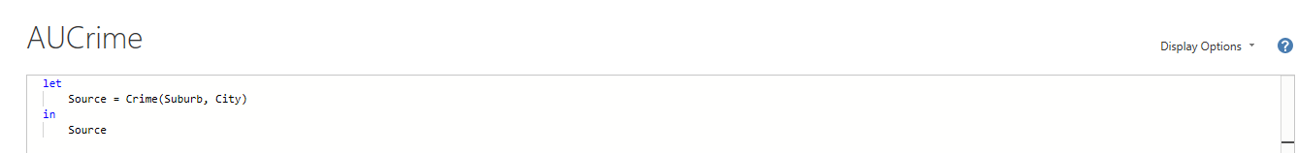

**Step 4: Select the Suburb and City to display the result accordingly**

**SAMPLE OUTPUT:**

**Task 29: Given suburb and city, display property value of the area within 1km radius in Column chart and line chart of 1 year, 5 years and 10 years value**

**Step 1: Write a stored procedure in Microsoft SQL Server Management Studio**

**Step 2: Connect to the Server, Database and Import the data using stored procedure in Power BI**

**Step 3: Create a list for Suburb and City. Create a new parameter for Suburb and City. Pass the parameter in the function.**

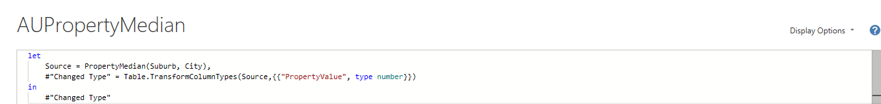

**Step 4: Select the Suburb and City to display the result accordingly**

**SAMPLE OUTPUT:**



